**User Login**

The user login page is where you will log into your student account and is necessary to participate in assignments.

Enter your username and password in the corresponding boxes and click on the login button to log into the application.

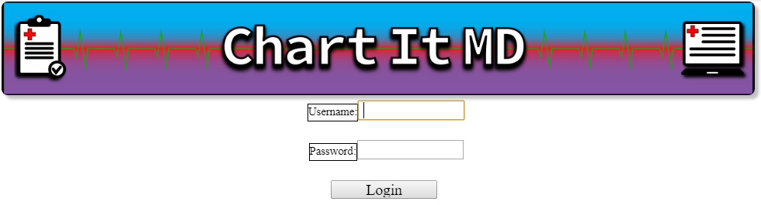

Login page

Having trouble logging in? Contact your instructor.

**Patient Contact**

The patient contact page is where the patient’s contact information such as their address, email, and phone number is inputted and saved.

The Email, addresses, and phone number are editable when in edit mode and the first and last name cannot be edited.

Clicking the save button will save the edits you made to the input fields and the cancel button cancels the edit without saving your changes

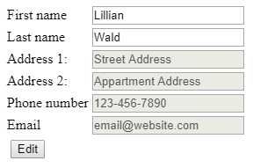 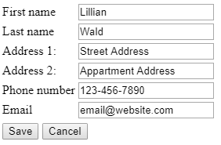  
 Page by default Page in edit mode

**Patient header bar**

The patient header bar is at the top of the page, and is what displays the patients information. It will be available on all of the pages other than the user login page.

The arrow in the top left corner of the bar will hide/show a majority of the content of the bar.

Clicking on the arrows on certain data fields will hide/show options to create a new entry for the field and showing more data from the corresponding field

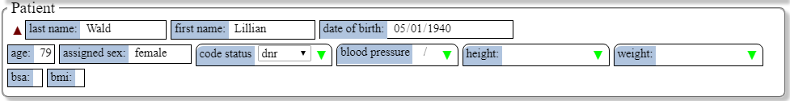Navbar opened



Navbar closed